*What’s the impact? Effectiveness of Aid in Burkina Faso*

Liam Coveney   
Indiana University  
B-365: Data Analytics & MiningBloomington, IN  
lcoveney@iu.edu

*Abstract*— Burkina Faso is one of the most underdeveloped nations in the world and receives large aid packages every year to support its progress. Often called into question in any such country however, is whether or not aid packages such as these have any real impact or if they are just a waste of money. This is an especially reasonable concern to to the prevalence of corruption in government and terrorism in the country, which could suggest political instability and a likelihood that aid is not used effectively. My goal in this report is to analyze whether or not aid in Burkina Faso has a significant effect on markers of the nation’s development or not, and if so how much and what does it suggest. After gathering data from several different sources regarding aid received and developmental markers for Burkina Faso I collected them all in one dataset and cleaned them such that I had no missing values or outliers. I analyzed the correlation between the significant attributes I was tracking and made note of the strongest relationships involving aid and a developmental statistic. I developed linear models of these relationships and tested them, finally determining that aid does has a statistically significant effect on development. This result should be explored further however, as there are likely untracked variables that have a large effect on the markers of development that I was tracking.

Keywords—Burkina Faso, Developmental Aid, Grant, Technical Cooperation Aid, ODA (Official Developmental Aid), Development, Correlation, Coefficient of Determination, GDP, Maternal Mortality Ratio (Deaths per 100,000)

# Introduction (*Heading 1*)

Burkina Faso is one of the least prosperous countries in the world, with very few natural resources and a poverty rate of 88.10% reported in 2021[1]. There are multiple active terrorist organizations and rampant corruption in the government. The government receives hundreds of millions of dollars every year in aid from organizations and countries around the world to help alleviate the humanitarian crises and develop the country. My goal in this report is to analyze how effective this aid is and what its impacts are for the country.

Effectiveness of Humanitarian Aid is a commonly discussed issue, with many studies into how much impact the money being sent to countries in need has. Most of the reports focus on a particular type of development, such as education or governmental development. This differs from my report in that I analyzed multiple variables to try and identify what aid affects most or doesn’t affect and get a general idea of the impact it has. In this report I will track indicators of development in Burkina Faso as well as amount of aid received, analyze the relationships between aid and those trackers, and determine whether or not aid has a significant effect on development of Burkina Faso.

# Methods

## Data Acquisition

Data was gathered on significant development markers and aid received over time in Burkina Faso from many different datasets. Data on the three main categories of aid received by Burkina Faso, Grants, Technical Cooperation, and ODA, were gathered from the OECD website[2]. Data on literacy rates were gathered from the Macrotrends website[3], as well as data on poverty rates[1]. GDP growth percentage data from each year was gathered from the World Bank Website[4], as were data on life expectancy at birth[5] and Maternal Mortality Ratio[**REFERENCE**]. Finally, all of this data was extracted from their respective datasets and gathered in one together.

## Data Cleaning and Preprocessing

The resulting dataset has 9 attributes and 65 datapoints, one from each year from 1960 to 2024. The columns for Poverty Rate and Literacy Rate each only have a few data points and are sparsely reported so I removed them. I removed the datapoints from years 1960-2000 because neither the Life Expectancy column nor the Maternal Mortality Ratio column had data for those years, and removed the datapoints from years 2017-2024 because there is no data on Aid that Burkina Faso received since then. I combined our grants, technical cooperation, and ODA received columns into one by adding them all and called it Total Aid. I did this because I are only analyzing how effective aid is, and don’t necessarily need to know what the aid was specifically for, just how much aid Burkina Faso received. It also minimizes outliers. I removed the year datapoint for the year 2006 after analyzing each attribute for outliers because the amount of aid received appears to be falsely reported.

## Correlation Analysis

I made plots of the developmental markers vs amount of aid received to determine potential relationships and did a correlation analysis of each attribute. I considered changing modifying columns for Maternal Mortality Ratio and Life Expectancy so that they instead represented the change in those variables from the year prior to minimize impact of unaccounted for variables. I opted not to because I found that my model was stronger without that change, as the large scale difference between attributed due to the modification weakened any relationships I had found and produced new outliers. I could have standardized the attributes but chose instead to return to my previous model. After identifying the strongest relationships I developed linear models of the most interesting ones and tested them to gather more information about them. This allowed me to evaluate the standard error, t value, p value, and coefficient of determination. From this I was able to determine whether or not Aid received has an effect on these markers of development, and if so how much of one.

# Results

The preprocessing and cleaning preformed on my data reduced its size greatly. While initially it had 9 attributes and 65 datapoints, after cleaning it only had only 5 attributes and 16 datapoints. A correlation matrix was created from this dataset shown below in Figure 1. Dark blue represents a strong positive correlation, white represents a correlation coefficient of 0, and dark red represents a strong negative correlation.

In the above matrix each box represents the correlation between the row and column it is part of. The blue diagonal line shows where rows and columns represent the same attributes, and thus correlation is 1. Since we are trying to analyze the effect aid has on developmental markers in a country we want to focus on those variables. We can see that there is a strong negative correlation between Maternal Mortality Ratio and Aid, and there appears to be a strong positive correlation between Aid and Life Expectancy. We also see a very strong relationship between Aid and Year, although this is not that interesting because it only means that Aid is increasing yearly which is not surprising.

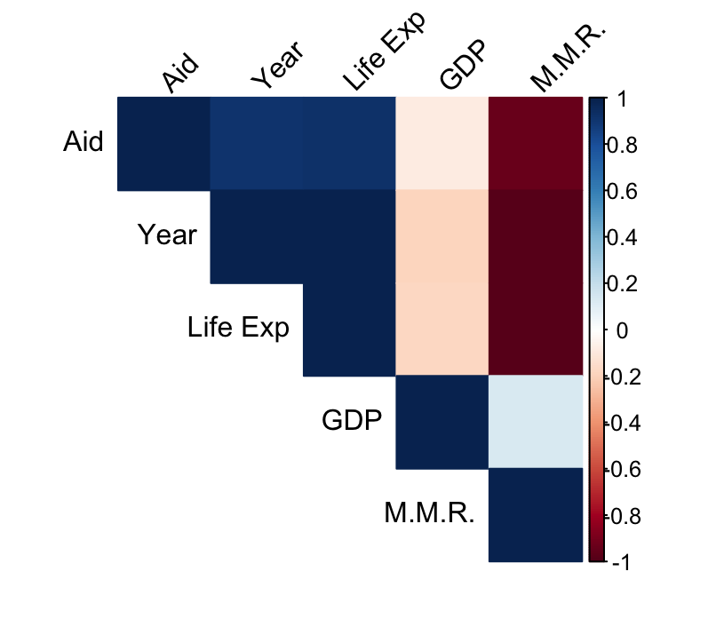

Correlation Matrix of Significant Variables

1. Figure 1. The above matrix represents the correlation coefficients of the row and column that intersect it. A strong positive correlation is represented by dark blue, while a strong negative correlation is represented by dark red, an white represents no correlation. M.M.R. stands for Maternal Mortality Ratio.

Analyzing these relationships further we can use R’s lm() function to develop linear models for the relationships between Aid and Maternal Mortality Ratio and Life Expectancy respectively. A summary of both models reveals a p-value of 6.54e-8 and coefficient of determination of 0.875 for the model of the relationship between Aid and Maternal Mortality Ratio, and a p-value of 3.22e-7 and coefficient of determination of 0.8432 for the model of the relationship between Aid and Life Expectancy. This suggests that roughly 85% of the variation in Maternal Mortality Ratio and Life Expectancy can be explained by the amount of aid received, and that aid does have a significant effect on certain development markers for Burkina Faso. This should be explored further however, because of the strong relationship between Year and Aid which makes it hard to determine how much of a role either variable has on the markers compared to each other.

# Discussion

My findings suggest that Aid received by Burkina Faso does have a significant effect on development, however there are limitations to the credibility of this test. There are an almost infinite amount of unaccounted for variables which could have an effect on these developmental markers, such as crime rate, corruption, etc, which could all have as much or more of an effect on the tracked markers. Additionally, the data I was able to find was extremely limited. The majority of time spent on this report went into collecting and preparing the data for use. Ideally I would be able to track more markers of development over more time, but there is not a lot of reported data on any factors that may be worth analyzing, especially before 2000.

For future research in this area, I recommend finding more reliable data or collecting new data and a well thought out standardization to get them to work well together. One of my biggest difficulties was in making the information provided by attributes make sense in terms of each other and having a better solution to achieve that could yield much more precise and insightful results. Variables that may be worth tracking include education (especially literacy or that of women), clean water access, corruption, poverty rate, and infrastructure, as these are all important factors to the development of a nation.

##### Author contribution Statement

I, Liam Coveney, am solely responsible for the work done and substance written in this report, while using datasets that were freely available online.

##### References

1. Macrotrends, “Burkina aso Poverty Rate 1994-2024,” 2024, [Online] Available: https://www.macrotrends.net/global-metrics/countries/BFA/burkina-faso/poverty-rate
2. OECD, “DAC2A: Aid (ODA) disbursements to countries and regions,” 2024, [Online] Available:https://data-explorer.oecd.org/vis?df[ds]=DisseminateFinalDMZ&df[id]=DSD_DAC2%40DF_DAC2A&df[ag]=OECD.DCD.FSD&dq=.DPGC.206.USD.Q&lom=LASTNPERIODS&lo=5&to[TIME_PERIOD]=false
3. Macrotrends, “Burkina Faso Literacy Rate 1994-2024,” 2024, [Online] Available: https://www.macrotrends.net/global-metrics/countries/BFA/burkina-faso/literacy-rate
4. World Bank Group “GDP growth (annual %) - Burkina Faso,” 2024 [Online] Available: https://data.worldbank.org/indicator/NY.GDP.MKTP.KD.ZG?view=chart&locations=BF
5. World Bank Group “Life expectancy at birth, total (years) - Burkina Faso,” 2024 [Online] Available: https://data.worldbank.org/indicator/SP.DYN.LE00.IN?locations=BF
6. World Bank Group “Maternal mortality ratio (modeled estimate, per 100,000 live births) - Burkina Faso,” 2024 [Online] Available: https://data.worldbank.org/indicator/SH.STA.MMRT?locations=BF